Brainstorm

& idea prioritization

Use this template in your own brainstorming sessions so your team can unleash their imagination and start shaping concepts even if you're not sitting in the same room.

## Before you collaborate

#### A little bit of preparation goes a long way with this session. Here’s what you need to do to get going.

##### 10 minutes

###### Team gathering

Define who should participate in the session and send an invite. Share relevant information or pre-work ahead.

###### Set the goal

Think about the problem you'll be focusing on solving in the brainstorming session.

###### Learn how to use the facilitation tools

Use the Facilitation Superpowers to run a happy and productive session.

**1**

## Define your problem statement

#### What problem are you trying to solve? Frame your problem as a How Might We statement. This will be the focus of your brainstorm.

##### 5 minutes

**PROBLEM**

**To predict how long the patient will stay in the Hospital which means length of Stay(LOS)**

**2**

## Brainstorm

#### Write down any ideas that come to mind that address your problem statement.

**10 minutes**

**MANIMARAN.M**

Revenue stats based on LOS of patients

Diagonishing the patient

Admission and discharge date

Collect data on the hospital bed occupancy rate

Generate timely reports to look over it.

Doctors shift time based on

the LOS of the patient

**SATHISH KUMAR.M**

**TIP**

You can select a sticky note and hit the pencil [switch to sketch] icon to start drawing!

# 

Let patients engage

with their own health histories with

easy access to medical records.

Factors affecting the services provided to the patients

Improve Treatment Methods To Adapt New Ones.

Monitoring patient's health

**3**

## Group ideas

#### Take turns sharing your ideas while clustering similar or related notes as you go. Once all sticky notes have been grouped, give each cluster a sentence-like label. If a cluster is bigger than six sticky notes, try and see if you and break it up into smaller sub-groups.

**20 minutes**

USER DATA COLLECTION AND INFORMATION

**TIP**

Add customizable tags to sticky notes to make it easier to find, browse, organize, and categorize important ideas as themes within your mural.

# 

Collect data on the hospital bed occupancy rate

Bring in all the

past records related to health care.

**4**

## Prioritize

#### Your team should all be on the same page about what's important moving forward. Place your ideas on this grid to determine which ideas are important and which are feasible.

##### 20 minutes

Collecting data from patient and evaluate the LOS

Sharing steps they can take to expedite the discharge process.

Keep the contact details of Staff and patients updated.

History of past admission in the hospital

Modernize Your New Patient Paperwork Process.

## After you collaborate

You can export the mural as an image or pdf to share with members of your company who might find it helpful.

**Quick add-ons**

###### Share the mural

**Share a view link** to the mural with stakeholders to keep them in the loop about the outcomes of the session.

###### Export the mural

Export a copy of the mural as a PNG or PDF to attach to emails, include in slides, or save in your drive.

**10 minutes** to prepare

**1 hour** to collaborate

**2-8 people** recommended

[**Open article**](https://support.mural.co/en/articles/2113740-facilitation-superpowers)

Date of admission and discharge

Collecting data from patient and evaluate the LOS

Sharing steps they can take to expedite the discharge process.

# 

Handling Large amount of Data

Optimize the treatment process for the LOS

Reporting of LOS to doctor's

### Key rules of brainstorming

View patient record frequently

identify patients of high LOS risk

Dashboard to predict the LOS of the patient

To run an smooth and productive session

DEVELOPMENT PROCESS

### Keep moving forward

###### Strategy blueprint

Define the components of a new idea or strategy.

###### [Open the template](https://app.mural.co/template/e95f612a-f72a-4772-bc48-545aaa04e0c9/984865a6-0a96-4472-a48d-47639307b3ca)

**Customer experience journey map**

Stay in topic.

Defer judgment.

Encourage wild ideas.

Listen to others.

### PAZHANISAMI.R

Time of discharge

Optimize the Allocation of Staffs for

necessaryeatment process for

the LOS

**SAKTHIVEL.T**

Collecting data from patient and evaluate the LOS

Improve Treatment Methods To Adapt New Ones.

Severity of diseases

Know the Areas where the hospital management lag the most

### Importance

If each of these

Doctors shift time based on

the LOS of the patient

Optimize the treatment process for the LOS

Know the Areas where the hospital management lag the most

Understand customer needs, motivations, and obstacles for an experience.

###### [Open the template](https://app.mural.co/template/b7114010-3a67-4d63-a51d-6f2cedc9633f/c1b465ab-57af-4624-8faf-ebb312edc0eb)

identify patients of high LOSrisk

Go for volume. If possible, be visual.

tasks could get done without any difficulty or cost, which would have the most positive impact?

###### Strengths, weaknesses, opportunities & threats

Identify strengths, weaknesses, opportunities, and threats (SWOT) to develop a plan.

|  |  |
| --- | --- |
|  |  |
|  |  |

###### [Open the template](https://app.mural.co/template/6a062671-89ee-4b76-9409-2603d8b098be/ca270343-1d54-4952-9d8c-fbc303ffd0f2)

**TIP**

Checking of beds in different states to get idea of where a shortage will reveal

identify patients of high LOS risk

Modernize Your New Patient Paperwork Process.

Prioritise patients with warning signs.

Handling Large amount of Data

Bring in all the

past records related to health care.

Illness and severity

Data exploration

Doctors shift time based on the LOS of the patient

Participants can use their cursors to point at where sticky notes should go on the grid. The facilitator can confirm the spot by using the laser pointer holding the **H key** on the keyboard.

History of past admission in the hospital

Prioritise patients with warning signs.

Make visualisations in such a way that everyone can understand it.

Number of patients by ward type

Nurse allocation

Checking of beds in different states to get idea of where a shortage will reveal

###### [Share template feedback](https://muralco.typeform.com/to/CiqaHVat?typeform-source=app.mural.co)

Checking of beds in different states to get idea of where a shortage will reveal

Make visualisations in such a way that everyone can understand it.

Sharing steps they can take to expedite the discharge process.

[**Share template feedback**](https://muralco.typeform.com/to/CiqaHVat?typeform-source=app.mural.co)

### Feasibility

Regardless of their importance, which tasks are more feasible than others? (Cost, time, effort, complexity, etc.)

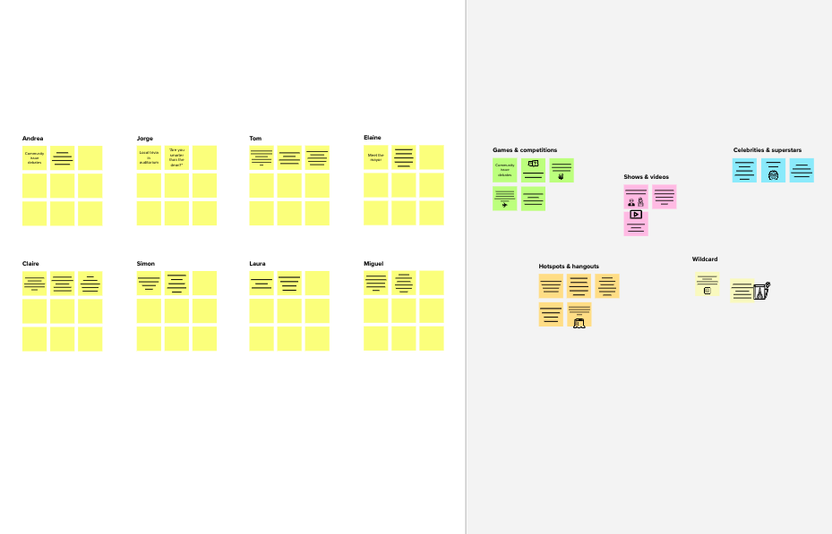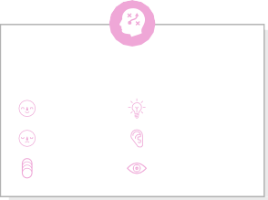

**Template**

**Need some inspiration?**

See a finished version of this template to kickstart your work.

[**Open example**](https://app.mural.co/template/e5a93b7b-49f2-48c9-afd7-a635d860eba6/93f1b98d-b2d2-4695-8e85-7e9c0d2fd9b9)